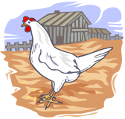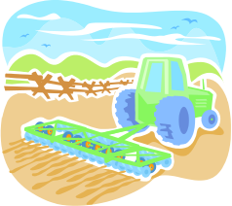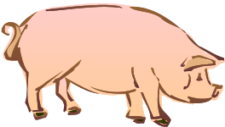
5th May 2017

Dear Parents/Carers,

As part of our topic about farm animals, we are hoping to take Reception Class children on a visit to Hesketh Farm, near Bolton Abbey, on Friday 16th May. We will be setting off from school at 9.15am and returning around 4pm.

Children do not need to wear uniform but should come in jeans or trousers, sensible shoes and a warm coat, to enable them to enjoy the facilities safely.

During the visit, the children may have the opportunity to be involved in the following activities:
- Meeting and learning about the animals
- Tractor and trailer ride
- Outdoor playground
- Straw maze
- Collecting eggs
- Feeding the lambs or calves.

We are asking for a voluntary contribution of £5.00 towards the cost of transport and entrance to the farm. Please bring this in an envelope with your child’s name clearly marked. Please complete the permission slip below and return to school as soon as possible.

Many thanks,
Mrs Smith
……………………………………………………………………………………………………………

I give permission for my child………………………………………………….. to visit Hesketh Farm

and enclose a voluntary contribution of £……………

Signed…………………………………………… Parent/Carer Date……………………..

