Friday 5th May 2017

Dear Parents

We have recently been told about some websites that could be very harmful for children.
Blue Whale , Lovoo and Woozworld are aimed at young people from aged 8 onwards and are not safe for pupils to use.

Please ensure you know which sites your child is visiting and talk to them about the risks involved.

To help you discuss this with your child we have provided a booklet for you to share.

If you have any concerns about your child being safe on the internet please come and talk to us at school.

Yours sincerely

Mrs E. J. Holliday 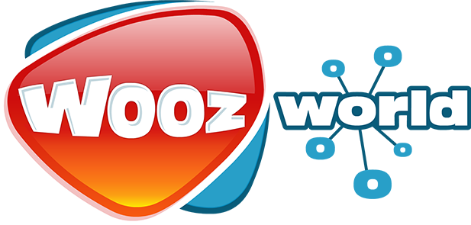
Headteacher


